MVC Step 2 (<https://docs.microsoft.com/en-us/aspnet/core/tutorials/first-mvc-app/adding-controller>)

MVC PowerPoint first

* In **Solution Explorer**, right-click **Controllers > Add > New Item... > MVC Controller Class**

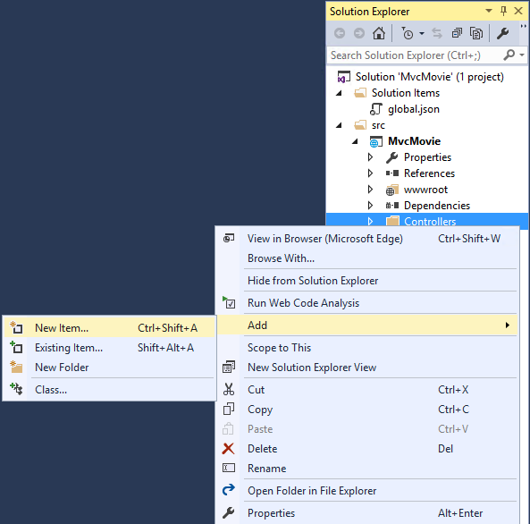1

* In the **Add New Item** dialog, enter **HelloWorldController**.

Replace the contents of Controllers/HelloWorldController.cs with the following:

Copy

C#

using Microsoft.AspNetCore.Mvc;

using System.Text.Encodings.Web;

namespace MvcMovie.Controllers

{

public class HelloWorldController : Controller

{

//

// GET: /HelloWorld/

public string Index()

{

return "This is my default action...";

}

//

// GET: /HelloWorld/Welcome/

public string Welcome()

{

return "This is the Welcome action method...";

}

}

}

Every public method in a controller is callable as an HTTP endpoint. In the sample above, both methods return a string. Note the comments preceding each method.2

The first comment states this is an [HTTP GET](http://www.w3schools.com/tags/ref_httpmethods.asp) method that is invoked by appending "/HelloWorld/" to the base URL. The second comment specifies an [HTTP GET](http://www.w3.org/Protocols/rfc2616/rfc2616-sec9.html) method that is invoked by appending "/HelloWorld/Welcome/" to the URL. Later on in the tutorial we'll use the scaffolding engine to generate HTTP POST methods.

Run the app in non-debug mode (press Ctrl+F5) and append "HelloWorld" to the path in the address bar. (In the image below, http://localhost:1234/HelloWorld is used, but you'll have to replace 1234 with the port number of your app.) The Index method returns a string. You told the system to return some HTML, and it did!

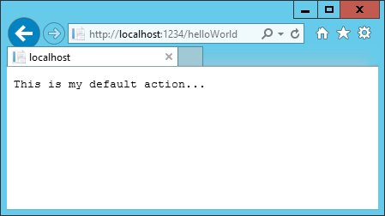

MVC invokes controller classes (and the action methods within them) depending on the incoming URL. The default [URL routing logic](https://docs.microsoft.com/en-us/aspnet/core/mvc/controllers/routing) used by MVC uses a format like this to determine what code to invoke:

/[Controller]/[ActionName]/[Parameters]

You set the format for routing in the Startup.cs file.

Copy

C#

app.UseMvc(routes =>

{

routes.MapRoute(

name: "default",

template: "{controller=Home}/{action=Index}/{id?}");

});

When you run the app and don't supply any URL segments, it defaults to the "Home" controller and the "Index" method specified in the template line highlighted above.

The first URL segment determines the controller class to run. So localhost:xxxx/HelloWorld maps to the HelloWorldController class. The second part of the URL segment determines the action method on the class. So localhost:xxxx/HelloWorld/Index would cause the Index method of the HelloWorldController class to run. Notice that we only had to browse to localhost:xxxx/HelloWorld and the Index method was called by default. This is because Index is the default method that will be called on a controller if a method name is not explicitly specified. The third part of the URL segment ( id) is for route data. We'll see route data later on in this tutorial.

Browse to http://localhost:xxxx/HelloWorld/Welcome. The Welcome method runs and returns the string "This is the Welcome action method...". For this URL, the controller is HelloWorld and Welcome is the action method. We haven't used the [Parameters] part of the URL yet.

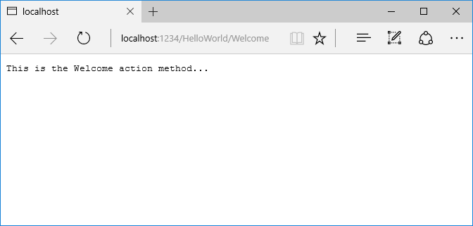

Let's modify the example slightly so that you can pass some parameter information from the URL to the controller (for example, /HelloWorld/Welcome?name=Scott&numtimes=4). Change the Welcome method to include two parameters as shown below. Note that the code uses the C# optional-parameter feature to indicate that the numTimes parameter defaults to 1 if no value is passed for that parameter.

Copy

C#

public string Welcome(string name, int numTimes = 1)

{

return HtmlEncoder.Default.Encode($"Hello {name}, NumTimes is: {numTimes}");

}

##### Note

The code above uses HtmlEncoder.Default.Encode to protect the app from malicious input (namely JavaScript). It also uses [Interpolated Strings](https://msdn.microsoft.com/en-us/library/dn961160.aspx).1

##### Note

In Visual Studio 2015, when you are running in IIS Express without debugging (Ctrl+F5), you don't need to build the app after changing the code. Just save the file, refresh your browser and you can see the changes.3

Run your app and browse to:

http://localhost:xxxx/HelloWorld/Welcome?name=Rick&numtimes=4

(Replace xxxx with your port number.) You can try different values for name and numtimes in the URL. The MVC [model binding](https://docs.microsoft.com/en-us/aspnet/core/mvc/models/model-binding) system automatically maps the named parameters from the query string in the address bar to parameters in your method. See [Model Binding](https://docs.microsoft.com/en-us/aspnet/core/mvc/models/model-binding) for more information.

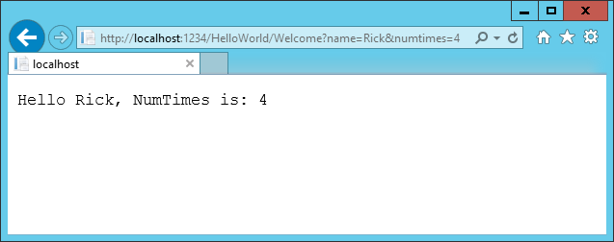

In the sample above, the URL segment (Parameters) is not used, the name and numTimes parameters are passed as [query strings](http://en.wikipedia.org/wiki/Query_string). The ? (question mark) in the above URL is a separator, and the query strings follow. The & character separates query strings.

Replace the Welcome method with the following code:

Copy

C#

public string Welcome(string name, int ID = 1)

{

return HtmlEncoder.Default.Encode($"Hello {name}, ID: {ID}");

}

Run the app and enter the following URL: http://localhost:xxx/HelloWorld/Welcome/3?name=Rick

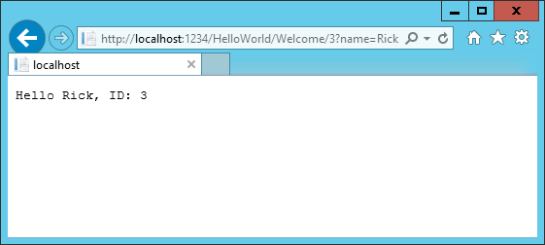1

This time the third URL segment matched the route parameter id. The Welcome method contains a parameter id that matched the URL template in the MapRoute method. The trailing ? (in id?) indicates the id parameter is optional.

Copy

C#

app.UseMvc(routes =>

{

routes.MapRoute(

name: "default",

template: "{controller=Home}/{action=Index}/{id?}");

});

In these examples the controller has been doing the "VC" portion of MVC - that is, the view and controller work. The controller is returning HTML directly. Generally you don't want controllers returning HTML directly, since that becomes very cumbersome to code and maintain. Instead we'll typically use a separate Razor view template file to help generate the HTML response. We'll do that in the next tutorial.